**Leader Overview**

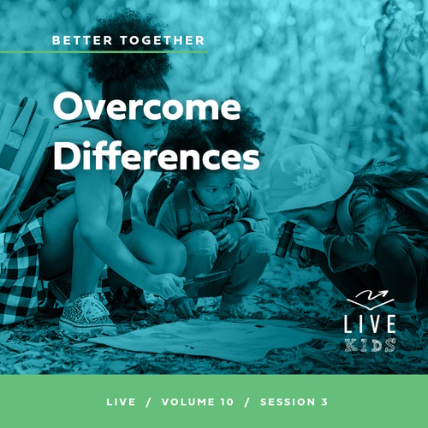

**Volume Overview**

**Better Together**

*The Christian life is never lived alone. When we become a Christian, we’re adopted into God’s family. We’re welcomed into a community. We’re meant to live and grow in faith together. But that takes humility and intentionality. We grow together as we pray and study Scripture together. We bear responsibility for one another by our encouragement and our honoring of those in authority. God is growing us together as one body, one family.*

**Session Overview**

**Overcome Differences**

*In this* **Live** *session, kids will discover the importance of overcoming disagreements with other believers in a healthy way. God has given us godly leaders who can help us solve disagreements the right way. With God’s help, we can work together with everyone in God’s family, even if we don’t always agree with them.*

**Bible Lesson**

The Church Meets to Navigate Challenges

[Acts 15:1–20](https://ref.ly/logosref/Bible.Ac15.1-20)

**Faith Fact**

We can solve disagreements with God’s help.

**Faith Verse**

[Ephesians 4:3](https://ref.ly/logosref/Bible.Eph4.3) (NLT)

Make every effort to keep yourselves united in the Spirit, binding yourselves together with peace.

**Preparing for the Session**

**Leader Preparation Time: 20–25 Minutes**

|  |
| --- |
| ***You Will Need***  ***Large Group***   * *Bible* * *Worship songs (Song suggestions: “Good Grace” by Hillsong United; “Speak Life” Lyric Video by TobyMac; “Tremble” by Bethel Music)* * *For groups not using a phone or tablet only, add:*   *• Projector or TV*  *• Laptop*  *•* ***Faith Fact Slide***  *•* ***Faith Verse Video*** *or* ***Slide***  *•* ***Bible Lesson Video***  ***• Teaching Point Slides 1–3***  ***Small Group***   * *Small whiteboard, one per group* * *Dry erase marker, one per group* * *Whiteboard eraser, one per group* * *Bibles for kids in the group to share* * ***Small Group Activity Pages 1 and 2****, one per kid* * *Pencils or pens, one per kid*   *To access session content and videos from a computer, visit:* [BibleEngagementProject.com/downloads](https://bibleengagementproject.com/downloads) |
| ***Getting Ready***  ***Large Group***   * *Download videos and slides if needed.* * *Select worship song(s) and have them ready to play.* * *Read the Bible Lesson Scripture to prepare for Teaching Time.*   ***Small Group***   * *Print copies of the* ***Small Group Activity Pages****, front to back if possible, one of each per kid.*   *First time leading* Live *for Kids? Check out the* [Facilitator Guide](https://0b769b0ed3569ef9d18b-f88d8272f61086866d50d048b43ef630.ssl.cf2.rackcdn.com/sites/biblengagementproject/Listen_Facilitator_Guide.pdf). |

**Large Group**

**30 Minutes**

*See what’s needed at the beginning of the session.*

**Introduction**

We are better together! Say that with me. *(Group response)* God’s Word tells us that’s true about everyone in His family. What about the times when we don’t feel like we’re “better together”? What am I talking about? I’m talking about when we disagree with other people. It makes sense that we would disagree with people who aren’t Christians, but do you think it’s possible to have disagreements with other Christians? *(Group response)* I know I’ve had disagreements with people who love Jesus like I do. How about you? *(Group response)*

Even though we all believe in Jesus, we can still disagree about things. We have preferences and even differing beliefs. So, how do we overcome disagreements when they happen in the Church? That’s what we’ll learn about today from a major disagreement Paul and some of the believers had in the Early Church.

**Faith Fact**

We will have disagreements, but how we handle them is what really matters. Our Faith Fact today is **We can solve disagreements with God’s help.**

• *Show the* ***Faith Fact Slide.***

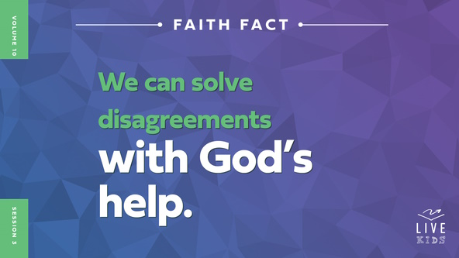

Let’s say the Faith Fact together. When we say, “God,” I want everyone to point up to remind us that God can help us when we disagree with each other. **We can solve disagreements with God’s help**. Let’s say that one more time. **We can solve disagreements with God’s help.**

**Game**

**Agree or Disagree?**

Let’s test some things that we might agree or disagree about right now. God made us all different, and we may like some things that other people don’t. Most of the time that’s okay. If you agree with the statement, stay seated and show me two thumbs up. If you disagree, stand up and put your hands on your hips.

• *Optional: If you want kids to move more, have them go to one side of the room if they agree with the statement and to the other side of the room if they disagree with the statement.*

• *Read the statements:*

• Hamburgers are better than hot dogs.

• Soccer is better than basketball.

• The beach is better than the mountains.

• The morning is better than the evening.

• Going to a movie is better than watching one at home.

• Ice cream in a cone is yummier than ice cream in a bowl.

• Summer is more fun than winter.

• Church is a great place to hang out with other believers.

• Playing video games is more fun than watching videos.

• The weekend is more fun than school days.

• Texting is better than talking on the phone.

See, it’s possible not to agree on everything and still like each other! Some disagreements are bigger than these kinds of things. God and our leaders can help us handle the disagreements that really matter, that are bigger. We’ll find out more about that after we worship together.

**Worship**

We can worship together even when we have disagreements. Worship unifies us and helps to remind us of what matters the most. Let’s worship God now by singing.

• *Lead the kids in singing one or two praise songs. See suggestions at the beginning of the session.*

**Bible Lesson**

I love it when we come together in worship. Let’s pray and ask God to show us how we can work together even when we have disagreements.

**Prayer**

|  |
| --- |
| *Dear God, thank You for making us all different and unique. Help us when we disagree to look to You for direction. Amen.* |

**Video Intro**

Before we look at the Bible story, let’s watch this video.

• *Play* ***Bible Lesson Video****.*

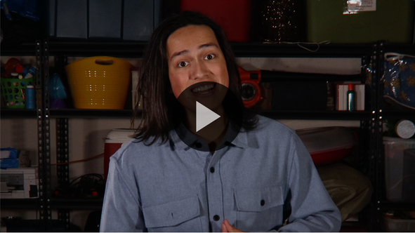

**Bible Story**

**The Church Meets to Navigate Challenges**

That video was a great lead-in to our Bible story today. Have you ever disagreed with someone? *(Group response)* Have you ever had a disagreement get so bad that you either stopped being someone’s friend or had to ask someone to help you talk things through with the person? *(Group response)*

When we have a major disagreement with someone, it’s a great idea to find someone like a parent, teacher, or pastor who can help us resolve the issue. That’s basically what happened in today’s Bible story. Paul and Barnabas were teaching one thing and some other men were teaching something different. It was a huge deal because it was about salvation, so they needed some outside wisdom to help them come to an agreement. Let’s find out what happened.

**Teaching Time**

It’s hard for us to imagine what it was like being a part of the Early Church. Their churches, pastors, and other leaders were kind of new and still figuring some things out. Paul and Barnabas were traveling and teaching people about Jesus and about how to be a Christian. Some of the teachings of Paul and Barnabas contradicted the old teachings. Remember, they didn’t have access to the Bible every day like we do either. So sometimes it was very hard to know who was teaching the truth and who was wrong. That sounds confusing to me! How could they find out what was God’s truth and what wasn’t? They needed God’s help.

Our Faith Fact reminds us that when we have disagreements that we can’t settle on our own, God is always there to help us. Our Faith Fact reminds us that **We can solve disagreements with God’s help**. Let’s read about how they handled this major disagreement. Grab your Bible or pull up a Bible app on your device. Turn to [Acts 17:10–15](https://ref.ly/logosref/Bible.Ac17.10-15).

• *In order to keep Large Group time moving along, we recommend that the leader reads the Scripture portions aloud.*

• *Optional: Remind the kids to mark this place with their Bible bookmark so they can read it on their own at home.*

**1. Some believers had a major disagreement**.

• *Show the* ***Teaching Point 1 Slide.***

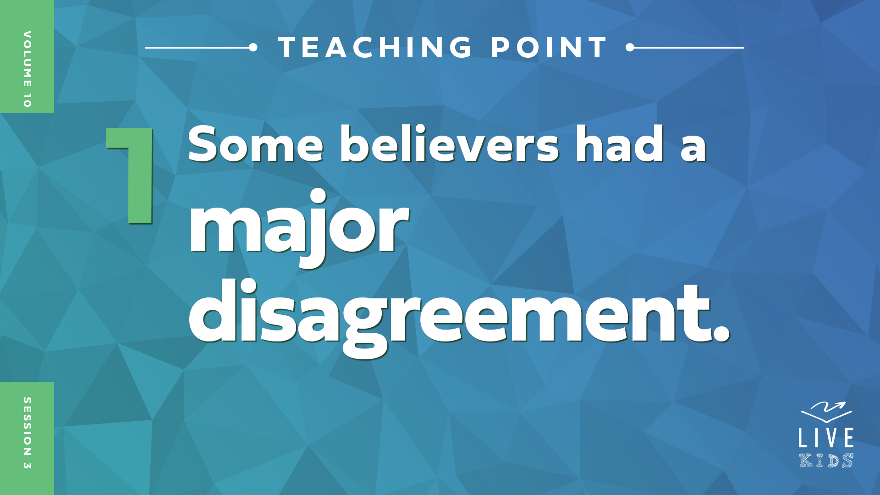

• *Read* [*Acts 15:1–2*](https://ref.ly/logosref/Bible.Ac15.1-2)*.*

Paul and Barnabas had been teaching the people the message God had given them everywhere they went. Most people who became Christians at that time were Jewish, but not everyone was. When this event took place, they were teaching new believers in Antioch, and many there weren’t Jewish. Then, other men started to teach the new believers.

Normally, it would be a great thing to have more people teaching new believers about Jesus, but that wasn’t the case here. You see, Paul and Barnabas had been teaching everyone that they could be saved by asking Jesus to forgive their sins and accepting Him into their life, and that’s it. Does that sound like the truth? *(Group response)* These other men were teaching that people who weren’t Jewish were not actually saved unless they also followed Jewish religious practices too.

People who were not Jews were called Gentiles. These teachers disagreed with Paul and Barnabas about what all needed to happen for Gentiles to truly be saved. Paul and Barnabas argued that the Gentiles should not be held to an old law that was meant for the Jews only. The other men refused to agree with them.

Why do you think this was such a major disagreement? *(Allow responses.)* It was a major issue because it was about salvation. That’s a big deal. They weren’t arguing over which song was better or who was a better teacher. The eternal destiny of the people who were being taught was on the line. That’s why Paul and Barnabas couldn’t just let the issue go. They couldn’t risk anyone teaching people something that wasn’t true.

**2. They went to church leaders to discuss the disagreement.**

• *Show the* ***Teaching Point 2 Slide.***

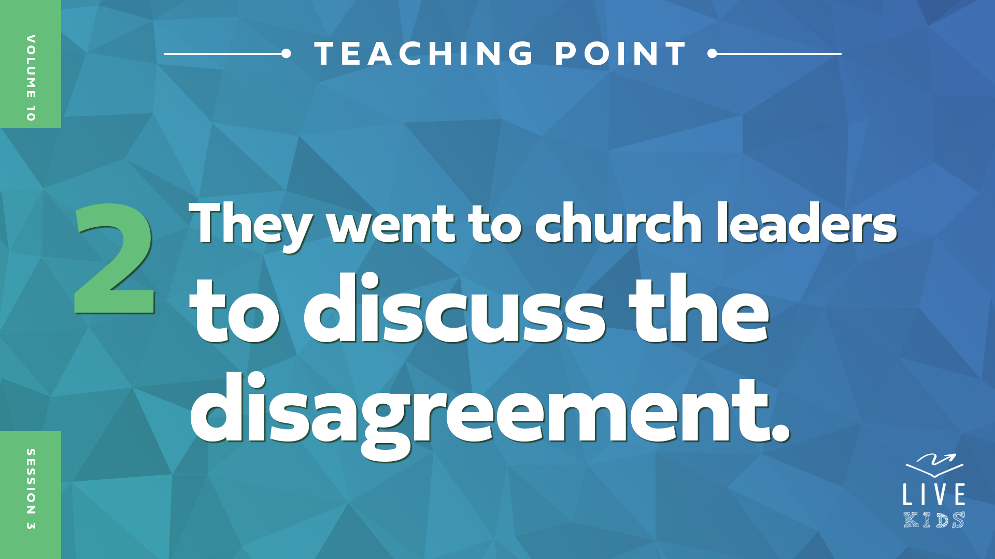

• *Read* [*Acts 15:3–6*](https://ref.ly/logosref/Bible.Ac15.3-6)*.*

These men argued back and forth until they decided to go to the church leaders to discuss the issue and resolve it. Paul, Barnabas, and some other believers took their question to the apostles and elders in Jerusalem. First, Paul and Barnabas shared the great news that many Gentiles were becoming believers and that God was moving among them. Then, others expressed that the Gentiles should be required to follow the law of Moses. The apostles and elders met to discuss how to handle the disagreement.

These early believers and leaders showed us that when we have disagreements, we should come together and talk things through. God has placed leaders in our life for a reason. Our leaders help us learn and grow. But they also correct us when we are wrong. I’m thankful that we have leaders with wisdom to help us know what to do. Let’s find out how the leaders in our Bible story resolved the disagreement.

**3. People gave proof for their argument, then an agreement was reached.**

* *Show the* ***Teaching Point 3 Slide.***

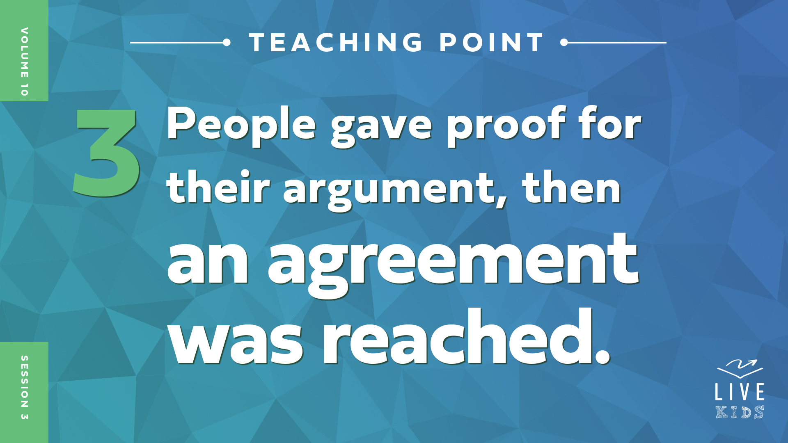

• *Read* [*Acts 15:7–20*](https://ref.ly/logosref/Bible.Ac15.7-20)*.*

Many of the leaders stood up to share their proof for why the Gentiles were saved without following the Jewish law. Let’s look at some of the proof they shared with the council.

**Proof 1–**Everyone hold up one finger and say, “One.” *(Group response)* Peter stood up and shared that God gave the same Holy Spirit to the Gentiles that He gave to the Jews when they were saved.

**Proof 2–**Everyone hold up two fingers and say, “Two.” *(Group response)* Paul and Barnabas stood up and shared about all the miraculous things God had done while they were ministering to the Gentiles. Why would God do so many miracles if He didn’t want the Gentiles to be saved?

**Proof 3**–Everyone hold up three fingers and say, “Three.” *(Group response.)* Lastly, James stood up and shared that the Gentiles being saved was predicted by the Old Testament prophets long ago. If the prophets said it would happen and it wasn’t true, then everything the prophets foretold would have to be questioned.

The decision was made that the Gentiles should not have to follow all the Jewish law. They figured out which laws had to be followed by all new Christians. The believers in Antioch were later filled with joy when they heard the decision that had been made.

**Prayer and Response**

*Consider playing a worship song softly in the background while kids pray.*

The believers made the right choice when they took their disagreement to the leaders over them. God gave these leaders His wisdom to know what was right and what was wrong. The leaders were able to help bring the disagreement to an end and establish truth for the believers to follow.

We also have godly leaders that God has given to us. In fact, you have leaders here right now who are available to pray with you, answer your questions, and help you. If you have a need or a question you need some wisdom to answer, a leader can talk with you and pray with you. Raise your hand if you would like to talk and pray with a leader. *(Group response)*

• *If time allows, let kids talk and pray with leaders now.*

Let’s pray together and thank God for the godly leaders He has given us.

**Prayer**

*Optional: Have the kids repeat phrases of the prayer after you.*

|  |
| --- |
| *Dear God, thank You for giving me godly leaders who can help me settle disagreements with others and answer tough questions. Help me to turn to my leaders and to You when I need wisdom and direction. Amen.* |

**Faith Verse**

Our Faith Verse talks about the importance of coming together with other believers in peace. If all we do is fight and disagree with each other, we are not following this instruction from God. Let’s say our Faith Verse and do the actions together.

• *Play* ***Faith Verse Video****.*

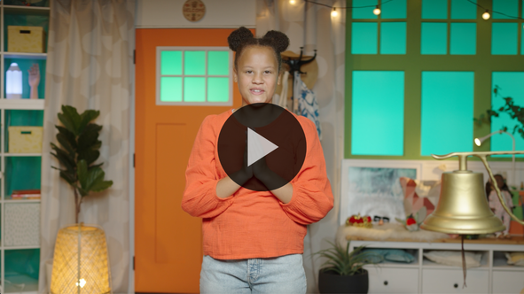

[Ephesians 4:3](https://ref.ly/logosref/Bible.Eph4.3) (NLT)

Make every effort to keep yourselves united in the Spirit, binding yourselves together with peace.

**Faith Fact**

Before we go to our small groups, let’s review our Faith Fact again. **We can solve disagreements with God’s help.**

• *Show the* ***Faith Fact Slide****.*



Let’s say our Faith Fact together one more time as peacefully and quietly as possible.

**We can solve disagreements with God’s help**. Remember to thank God and your leaders this week for all they do to help us become better together.

• *Dismiss kids to Small Group time or to go home if your group time ends here.*

**Small Group**

**30 Minutes**

*This section can be done in conjunction with the large group or on its own if you do small groups with your kids. During Small Group time, the goal is to connect the kids with the Word of God and to each other. All activities are led by the small group leader.*

**Group Connection**

**Solve It!**

|  |
| --- |
| ***You Will Need***   * *Small whiteboard, one per group* * *Dry erase marker, one per group* * *Whiteboard eraser, one per group*   *No prep is needed for this activity.* |

Are you good at solving puzzles? *(Group response)* We will see! For each round, I will draw dashes for letters in a word that connects to our Bible story. I’ll go around the circle and each of you will have a chance to guess a letter that could be in the word. If you think you know the word and can solve it when it’s your turn, say, “Solve it.” Then shout the word you think it is.

• *For each round, choose a word and draw dashes on the whiteboard for each letter in the word. For example: Better = _ _ _ _ _ _*

• *Better*

• *Together*

• *Acts*

• *Christian*

• *Disagree*

• *Wisdom*

• *Paul*

• *Peter*

• *Allow each kid to guess a letter or try to solve the word. If the letter is in the word, write the letter in the correct spot. If the letter is not in the word, write the letter at the top of the board so that no one will try to guess it again.*

• *Keep playing rounds with new words until you run out of words or time to play.*

Some of those words were easy to solve, but others were hard. If only all disagreements were so easy to solve! That’s why it’s important to remember our Faith Fact. Let’s say it together. **We can solve disagreements with God’s help.**

**Bible Lesson Recap**

• *If small group activities are not immediately following large group time, you may want to read the Bible story passage before the discussion.*

|  |
| --- |
| ***You Will Need***   * *Bibles for kids in the group to share*   *No prep needed for this activity.* |

**Bible Story Review: The Church Meets to Navigate Challenges** [**Acts 15:1–20**](https://ref.ly/logosref/Bible.Ac15.1-20)

Paul and Barnabas were busy doing ministry and telling people about Jesus in a town called Antioch. Unexpectedly, some other men showed up and contradicted part of what Paul and Barnabas had been teaching. The other men wanted to add to what new Christians who were Gentiles had to do to be saved. This disagreement was important enough to take it to the church leaders in Jerusalem. The leaders would have the wisdom to know what was right.

Both sides presented their cases, and the church leaders decided that Paul and Barnabas were preaching the truth. God had given the Gentiles the Holy Spirit and allowed Paul and Barnabas to perform many miracles among the Gentiles. Before that, the Old Testament prophets had foretold that all of this would happen. The Gentiles were filled with joy when they heard that they had indeed been saved through their faith in Jesus.

• *Give each kid a Bible and read the Bible story together.*

**Group Discussion**

*Feel free to use all or just a few questions as a jumping-off place for good discussion. Questions marked with * are designed for more conversation. Adjust the questions based on the age or maturity of your group. Typically, older kids will be able to dive a little deeper than younger ones.*

**Questions**

* Why was the disagreement in the Bible story such a big deal?

How do you think the Paul and Barnabas felt when they heard other people teaching a message they disagreed with?

* Why would these people have wanted to make it hard for the Gentiles to become followers of Jesus?

Where did the believers go to settle their disagreement?

What is the correct way to solve disagreements in the church?

How do you think the solution to this disagreement helped the Early Church become more unified?

How do you think the Gentiles who had been saved reacted to the council’s decision?

* Who do you go to for help when you disagree with someone else?

How can God help us get along with someone we disagree with?

**Live It**

**Faith Fact**

Our Faith Fact today is **We can solve disagreements with God’s help**. The believers were able to solve their major disagreement with God’s help through the church leaders in Jerusalem. That council was made of godly leaders who were put in place to help the Early Church solve issues like this one. Can you imagine what would have happened if the believers hadn’t asked for help? Disagreements like this one could have torn the Early Church apart and made everyone question the important message they were sharing about Jesus. That didn’t happen because the believers turned to godly leadership for wisdom.

**Challenge**

If you find yourself in a disagreement or argument with someone this week, find a leader God has placed in your life and ask them to help. If you have a hard question that you need answered, ask a leader if they can help you find the answer. God never meant for us to figure out everything on our own. That’s why we are better together.

**Prayer**

*Finish group discussion by sharing prayer requests and praise reports. Keep track of your small group’s prayer requests and review them each time you meet.*

• *Have kids share and pray for each other’s prayer requests.*

|  |
| --- |
| *Dear God, help us to turn to the leaders You have placed in our life when we need help. We want to work together with other believers, not against them. Amen.* |

**Faith Verse Review**

Our Faith Verse is [Ephesians 4:3](https://ref.ly/logosref/Bible.Eph4.3). It reminds us of how important it is to work together with other believers and keep the peace.

• *Play* ***Faith Verse Video****.*



[Ephesians 4:3](https://ref.ly/logosref/Bible.Eph4.3) (NLT)

Make every effort to keep yourselves united in the Spirit, binding yourselves together with peace.

Let’s say it a couple of times before we do a fun Faith Verse activity together.

• *Say the verse as a group a couple of times.*

**Faith Verse Fun**

**Verse Opposites**

Who thinks they have the Faith Verse memorized? *(Group response)* That’s awesome! We’ll have fun saying the Faith Verse in opposite ways today. For example, if I say the verse loud, you will say the verse quietly. Do you think you understand what to do? *(Group response)* Great! Let’s play!

• *Lead the verse a couple times. Then, let kids take turns choosing an opposite. Ideas include the following: loud/quiet, fast/slow, low-pitched/high-pitched, sing/monotone, etc.*

Opposites can be a lot of fun. If you haven’t memorized the Faith Verse yet, keep practicing. I know we can all do it!

**Activity Page**

**Solving Disagreements**

|  |
| --- |
| ***You Will Need***   * ***Small Group Activity Pages 1 and 2****, one per kid* * *Pencils or pens, one per kid*   ***Getting Ready***   * *Print copies of the* ***Small Group Activity Pages****, front to back if possible, one of each per kid.* |

Disagreements with other people can be frustrating. That’s why we must remember today’s Faith Fact. **We can solve disagreements with God’s help**. I’ve got a step-by-step guide to help us remember today’s Bible story and then use it to solve disagreements we might have with others.

• *Hand out a copy of* ***Small Group Activity Pages 1 and 2*** *and a pencil to each kid.*

Look at the pictures of Paul and Barnabas. As we complete this Solving Disagreements flowchart from their perspective, we’ll need to recall what happened in the Bible story. Let’s do that together.

• *Work through the flowchart with the kids, discussing possible answers for each section.*

Paul, Barnabas, and the church leaders are great examples of how to solve disagreements with God’s help. Now, let’s think about how we can use this flowchart to solve our own disagreements.

• *Turn over the page or hand out the second part of the activity.*

Take a moment and write in a disagreement you are having with someone. Then, fill out all the sections that you can. Remember, I’m here to help if you need advice about what to do in your situation. This can be a helpful tool to use anytime you have a disagreement with someone and can’t figure out how to resolve it.

**Dismissal**

As Christians, we will have disagreements with each other, but now we know how to handle them in God’s way. We can find ways to remain in peace with each other and settle our disagreements with God’s help. Let’s pray together one more time.

**Prayer**

|  |
| --- |
| *Dear God, thank You for helping us understand how to settle our disagreements with each other. Help us find ways to work together to build Your kingdom even if we don’t always agree. Amen.* |

**Faith Fact Recap**

• *Show the* ***Faith Fact Slide****.*



Remember today’s Faith Fact. **We can solve disagreements with God’s help**. You can ask God for help and wisdom anytime and anywhere. I can’t wait to get together again next time. See you then!

• *Send home the* ***Small Group******Activity Pages 1 and 2.***

• *Remind parents that there are* ***Family Devotions*** *available on the app to do with their kid.*

• *Tell everyone the date and time for the next session.*